Stability of Large Language Model Outputs Under Prompt Perturbation
Abstract
Large language models often produce different responses to prompts that are semantically equivalent but worded differently, a phenomenon commonly referred to as prompt sensitivity. However, because these models also generate non-deterministic output under standard sampling, an observed difference between two prompt versions may reflect either the wording change or the model’s own sampling randomness, and most existing studies do not separate these two sources of variation. This study proposes an empirical framework that disentangles perturbation effects from sampling noise by establishing, for each prompt, a noise baseline derived from multiple generations under fixed decoding parameters. Five categories of everyday, non-adversarial prompt perturbations (paraphrasing, reordering, formatting changes, context injection, and surface noise) will be applied to benchmark items drawn from four task types: factual question answering, mathematical reasoning, code generation, and open-ended writing. Two complementary metrics, semantic similarity (measured with Sentence-BERT) and task correctness will be used to examine whether the noise-corrected sensitivity ranking of perturbation types is consistent across task types, and whether semantic drift is associated with changes in correctness. The study aims to provide a reusable, cross-task methodology for quantifying prompt sensitivity that accounts for the model’s own output variability.

- Introduction
When using large language models (LLMs) for everyday academic tasks, I repeatedly noticed a pattern: when I phrased the same question in different ways, by reordering clauses, choosing different wording, or adding a polite remark, the model’s answer sometimes changed noticeably, even though the two phrasings appeared to express exactly the same intent to me. This observation is the starting point of this study. By treating the prompt as the input, the generated text as the output, and changes in wording or structure as perturbations, forms the basic framework of this study. The sensitivity of large language models to prompt wording is a central, yet still insufficiently characterized issue in assessing their reliability. Users typically assume that as long as the underlying intent of a question remains unchanged, the model’s response should also remain largely consistent. Whether this assumption holds, has not yet been examined through quantitative research.
Prompt robustness is a perspective of measuring LLM stability towards perturbated prompts. It is a vital measure of the LLM’s usability especially under academic background. This concept differs from the accuracy of the LLM as accuracy traces the correctness of its output and prompt robustness ensures that the output remains stable under semantically equivalent prompt variations.
The noise baseline, the instable output of LLM with the same prompt input, must be excluded from calculations of prompt robustness. Results by Haase et al. show that the proportion of variance explained by the model’s own sampling randomness ranges from 10% to 33.7%, sometimes even larger than the effect of the prompt itself. [5] Thus, this study supports the idea that by establishing a noise baseline through repeated sampling, the study will be able to distinguish between the real effects of the perturbations and the effects of sampling randomness.
This study will try to combine the ideas from the studies mentioned above. Based on Haase et al. [5], the variance in output from the same prompt will be measured and quantified, providing a baseline for the randomness of the model used. Drawing on the research of POSIX [3], the effect of different prompt perturbation types will be assessed across multiple task types. The changes in the prompt will be designed using the method from PromptBench [1] and Agrawal et al. [2].

- Related Works
The idea that LLMs are sensitive to prompt is first characterized systematically in the adversarial robustness research. PromptBench includes four levels of perturbations: character-level, word-level, sentence-level, sematic-level across 8 task types and 13 data sets. Their results shows that the effectiveness of attacks highly varies among perturbation levels, with word-level perturbations being the most potent, leading to an average of 33% in performance decline across all datasets. [1]
Chatterjee et al. proposed POSIX, a metric that converts sensitivity into a single computable value by measuring the relative change in the log-likelihood that a model assigns to the same response before and after an intent-preserving rephrasing [3]. This approach has the advantage of producing a single comparable score, but it requires access to the model’s internal token probabilities and is therefore inapplicable to most commercial models that are only accessible through an API. Notably, their experiments also showed that for multiple-choice tasks, changes to the prompt template are the dominant source of sensitivity, whereas for open-ended generation tasks, paraphrasing is the dominant source. This finding suggests that which type of perturbation has the greatest impact on output may itself depend on task type, although POSIX was not used to compare multiple task types systematically within a single framework.
Agrawal et al. examined the problem at the level of task instructions. By applying character-level and word-level edits to the instructions of classification tasks (CoLA, QNLI, and SST-2), they found that such seemingly minor changes substantially reduce downstream performance, and proposed mitigation strategies such as self-denoising [2]. This work shows that prompt sensitivity arises not only in the wording of individual questions or examples, but also in the wording of task instructions, and that its magnitude is large enough to be of practical concern to developers.
A related quantitative approach was proposed by Errica et al., who defined two metrics for classification tasks: sensitivity, the entropy of the predicted class distribution across multiple semantically equivalent rephrasing of the same input, and consistency, the similarity of predicted distributions across different inputs belonging to the same class [4]. To eliminate interference from the randomness inherent in generation, they set the decoding temperature to zero so that model behavior is close to deterministic, allowing any observed change in predictions to be attributed to the rephrasing itself. While this design effectively isolates the effect of rephrasing, it also assumes that model output is approximately deterministic and does not address how to separate the variation caused by rephrasing from the variation caused by sampling itself when the model generates at a non-zero temperature, which is the common setting for open-ended tasks such as creative writing or code generation.
This issue was quantified directly in a more recent study. Haase et al. performed a variance decomposition analysis across 12 large language models and 10 creative writing prompts, generating 100 outputs per combination (12,000 generations in total), and found that, depending on the specific metric, the proportion of variance explained by the model’s own sampling randomness ranges from 10% to 34%, comparable to or even larger than the effect of the prompt itself. They argue explicitly that evaluations based on a single generation conflate sampling noise with genuine prompt or model effects [7]. This finding provides direct empirical motivation for the core methodological design of the present study, which establishes a noise baseline through repeated sampling and compares perturbation effects against it: without first subtracting sampling noise, an observed drift after perturbation could simply reflect sampling randomness rather than the perturbation itself.
PromptBench [1] and the work of Agrawal et al. [2] show that perturbations of the prompt can significantly affect model output, but the former focuses on intentionally designed malicious prompt perturbations and the latter is validated only on classification tasks. POSIX [3] suggests that the pattern of perturbation sensitivity partially depend on task type but does not provide a quantitative comparison across task types. Errica et al. [4] provided a method to measure to what extent an output changes when prompts are changed. However, their study was limited to cases where models only give the same output each time. Additionally, open-ended tasks were not included in this study. Haase et al. [5] demonstrate that the sampling noise during the experiment cannot be ignored. However, their study focuses on whether output variations is created by the change in prompt or the model itself. The effect of specific types of prompt perturbations on output stability were not investigated.

- Research Question
RQ1. Applying a noise-baseline correction (that is, subtracting the random variation arising from the model’s own repeated generations), is the ranking of the five perturbation types (paraphrasing, reordering, formatting changes, context injection, and surface noise) by their effect on output semantic similarity consistent across the four task types (factual question answering, mathematical reasoning, code generation, and open-ended writing), or is this ranking itself task-dependent.
RQ2. For tasks with a well-defined correctness criterion (factual question answering, mathematical reasoning, and code generation), is there a statistically significant association between the degree of semantic drift (the magnitude of the similarity decreases) and the probability that correctness changes (from correct to incorrect, or vice versa)? Does this association have the same strength across task types? Open-ended writing is excluded from this analysis because it lacks an objective correctness criterion; consequently, the conclusions of RQ2 apply only to the three tasks above, and whether they generalize to open-ended generation requires further study.

- Methodology
  - Tasks and Benchmark Data
To avoid the selection bias that would result from constructing all items independently, and to ensure that results are comparable, benchmark prompts will be sampled from established public datasets: factual question answering will be drawn from SQuAD V2, mathematical reasoning from GSM8K, code generation from HumanEval, open-ended writing from Alpaca. Each dataset draws 10 items of prompts. Given that open-ended questions do not contain sample answers, prompts for this task will be used only for the semantic drift analysis and will not be included in the correctness analysis of RQ2.
  - Perturbation Design
Drawing on the perturbation taxonomies proposed in PromptBench [1] and by Agrawal et al. [2], and reflecting this study’s focus on natural everyday rephrasing rather than adversarial attack, five perturbation types are defined: paraphrasing (meaning-preserving rewording), reordering (rearranging sentences or the order in which information is presented), formatting changes (such as converting text to a list or adding or removing polite phrases), context injection (adding background information unrelated to the question), and surface noise (simulating unintentional spelling or punctuation errors that occur in real user input, such as missing letters or extra spaces, rather than systematic adversarial attacks). One version of each of the five perturbation types will be generated for every benchmark prompt. All generated perturbed versions will be manually checked to confirm that they are semantically equivalent to the original prompt; versions that fail this check will be regenerated, to ensure that any subsequent difference in output reflects a change in wording rather than a change in the question itself.
  - Noise Baseline Design
This is the core of the proposed methodology. The work of Haase et al. shows that the variance contributed by the model’s own sampling randomness can reach roughly thirty percent of total output variance, on the same order of magnitude as the effect of prompt rewording itself [2]. This implies that if each prompt version is used to generate only a single output, an observed drift after perturbation could simply reflect sampling noise. To rule out this confound, a noise baseline design is introduced. The distribution of semantic similarities among the multiple outputs generated from the same prompt constitutes that prompt’s noise baseline. The similarity between the original prompt and each perturbed version will then be compared against this baseline, and a decrease in similarity will be attributed to a perturbation effect, rather than to sampling noise, only if it significantly exceeds the variation observed within the noise baseline.
  - Model Selection
This study uses a low-cost commercial API model, GPT-4o-mini for output generations. Paraphrasing requires the use of LLM for perturbation generation, drawing on the research of POSIX [3], GPT-3.5-Turbo will be used.
  - Measurement Metrics
Semantic drift is defined as the decrease in semantic similarity between outputs generated from benchmark prompts and perturbed prompt from the same large language model. The degree of semantic drift in model output will be measured as the cosine similarity between the original and perturbed outputs, computed using Sentence-BERT embeddings [6]. For RQ2, task performance is measured using a task-specific automatic evaluators. Factual QA uses a continuous score rating ranging from 0 to 1 based on calculations of answer containment and token overlap, as the LLM may produce a longer answer than sample answer provided in SQuAD V2. If similarity between LLM output and sample answer is calculated, outputs with whole sentences will be given a lower score despite containing the correct answer. Mathematical reasoning uses a final answer correction after the answer extraction. Code generation tasks use a functional correctness based on unit-test execution provided with each HumanEval item.

- Experiments
  - Experimental Setup
This research uses four task types described in the Methodology section. 50 benchmark prompts will be selected using stratified random sampling with a fixed random seed for each type of task. A total number of 200 benchmark prompts will be selected from four datasets mentioned in the previous section.
All outputs will be generated using GPT-4o-mini through OpenAI API. The same generation settings will be used for both original and perturbed prompts: the temperature is set to 0.7 and top-p is set to 0.9. The temperature allows non-deterministic generation while keeping the decoding composition constant across all generations, allowing for the observation of ordinary sampling variations. No maximum token output will be set to ensure all answers of the LLM is shown fully. The settings are held constant to ensure that all semantic drift is caused by either prompt perturbation or noise baseline.
  - RQ1: Noise-Corrected Semantic Drift
    - Sampling-Noise Baseline
Given perturbations in prompt does not account for all semantic drift of the output, a noise baseline is introduced to eliminate the model’s own sampling randomness. During pilot trials, it has been noticed that the output semantic drift varies among different task types. Thus, the sampling-noise baseline is designed to be task specific. For each prompt, five repeated outputs will be generated using the same decoding parameters, producing a total of 1000 output for noise baseline calculation. The repeated output will be compared pairwise using Sentence-BERT cosine similarity, producing 10 within-prompt similarity results that will be used to calculate the sampling-noise baseline. Mean within prompt similarity is thus calculated by the average of the 10 pairwise similarity among repeated outputs. Sampling noise drift is further calculated using the formula:
$$sampling noise drift=1- mean within prompt similarity$$
    - Perturbation Drift Calculation
Perturbation Type | How it was added in the study | Method Source
Paraphrasing | The original prompt or main instruction is rewritten with GPT-3.5-Turbo under a meaning-preservation instruction. The generated paraphrase is checked against the original prompt. If it changes the answer target, task constraints, numbers, entities, examples, or code signature, it is rejected and regenerated. | POSIX [3]
Reordering | The prompt is separated into components such as instruction, context, question, constraints, examples, and output requirement. These components are rearranged into a different order while keeping the same information. | Haase et al. [5]
Formatting changes | The prompt content is converted into a different presentation format, such as bullet points, numbered fields, labels, separators, capitalization changes, or answer markers. | POSIX [3] and Haase et al. [5]
Context injection | One neutral, irrelevant, non-conflicting sentence is inserted before or after the main task instruction. The inserted sentence must not provide evidence, hints, examples, assumptions, or new task conditions. | PromptRobust [1]
Surface noise | Minor spelling, punctuation, spacing, insertion, omission, transposition, or substitution errors are added to non-critical instruction words only. | POSIX [3]
Every benchmark prompt will come with 5 perturbed prompts, creating a total of 1000 perturbed prompts. Each perturbed prompt was then submitted to GPT-4o-mini five times using the same generation settings as the original prompts, producing 1000 perturbed outputs. The final output consists of 20 semantic drift numbers composed of the combinations between 5 perturbation types and 4 task types
  - RQ2: Drift-Performance Association

- Result and Analysis
  - Results for RQ1
In this section, the results for RQ1 from 1000 LLM output generations will be presented.
Task type | Num of prompts | Mean with-in prompt similarity | Mean sampling noise drift | SD of mean sampling noise drift
Factual QA | 50 | 0.971166 | 0.028834 | 0.037073
Math reasoning | 50 | 0.938495 | 0.061505 | 0.028832
Code generation | 50 | 0.933042 | 0.066958 | 0.060519
Open-ended writing | 50 | 0.907748 | 0.092252 | 0.062151
Table ? : Sampling noise drift calculated for four task types.
In Table ?, the mean with-in prompt similarity of all four task types shows a relatively high value, with the task type Factual QA having the highest mean with-in prompt similarity of 0.971166 and the lowest mean with-in prompt similarity 0.907748 from open-ended writing. Mean with-in prompt similarity shows the stability of LLM output, with a higher value indicating a higher similarity when prompts are repeatedly provided to the LLM, which the repeat number is 5 in this experiment, and vice versa. The standard deviation of the mean sampling noise drift has been showed to have a relatively large value compared to the mean sampling noise drift. In order to determine whether statistical significance differences are present between groups, multiple statistical tests, including one-way ANOVA, Kruskal-Wallis, Levene median and Turkey, are used as a mathematical analyzing tool towards determining the relation between sampling noise drift and task type. The statistical results are shown below:
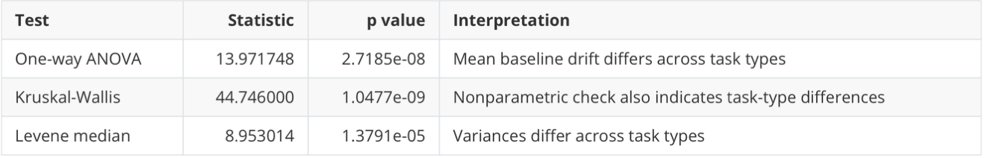
Table?: Statistical analysis results of sample noise baseline across different task types.
All results of the statistical tests shows that the mean baseline drift varies across the four task types, proving that there is a need for the task specific noise baseline design. In order to determine specifically whether statistically significant differences exist between every two task types, Tukey HSD Post-Hoc Comparisons are introduced. The results are shown below:
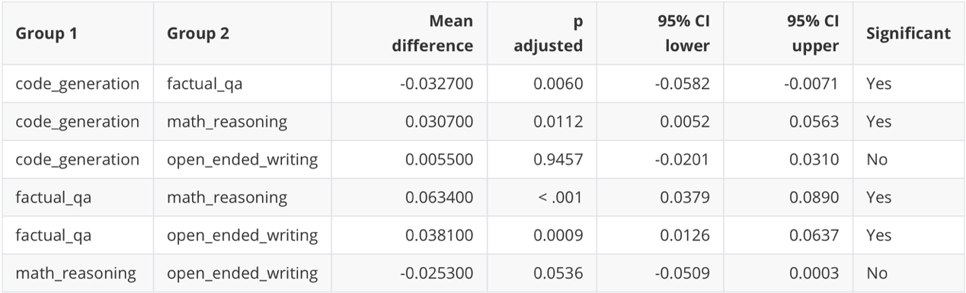
Table ?: Between tasks results of Tukey HSD
From the four statistical tests, it can be derived that the LLM’s performance is significantly more stable when performing factual QA tasks than code generation math reasoning and open-ended wiring under unperturbed circumstances.
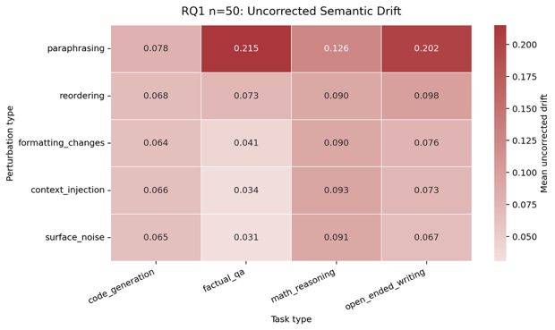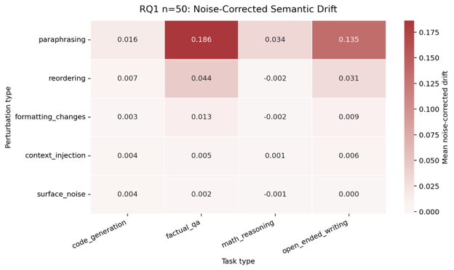
Figure ?: Heat map for RQ1 showing the perturbation drift of LLM outputs before and after baseline correction.
Figure? shows the perturbation drift before baseline correction. The overall perturbation drift shows a range of 0.184, ranging from 0.031 produced by factual QA under the perturbation of surface noise to 0.215 also produced by factual QA under the perturbation of paraphrasing. Specifically, the open-ended writing factual QA show a greater perturbation drift compared to the other task types, corresponding with the researcher’s expectation that LLM will be more sensitive to perturbations when performing tasks without a definable sample answer.
Figure? shows the perturbation drift after baseline correction. The heat map contains both positive and negative values: when the value is negative, it indicates that the perturbation drift calculated previously is completely caused by the sampling noise drift rather than the perturbation; when the value is positive, the current perturbation drift value is caused by perturbations in the LLM prompt. Comparing across perturbation types, data shows that LLM has performed a relatively strong resistance against surface noise, with perturbation drift ranging from -0.001 to 0.004. On the other hand, paraphrasing has been shown to be the most portent perturbation, showing a relatively strong ability to impede the performance of LLM under open-ended writing tasks. Comparing across task types, it can be observed that both math reasoning and code generation are relatively unsusceptible to all perturbations. However, the semantic perturbation drift cannot directly equate to model performance. Especially when the LLM is dealing with word level writing tasks, the change in wording or reordering of sentences may lead to larger similarity drift. Therefore, RQ2 is introduced to evaluate the correctness of LLM output under perturbation.
6.2 Results from RQ2
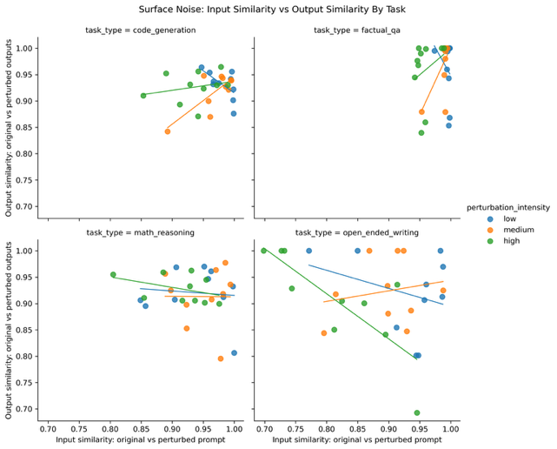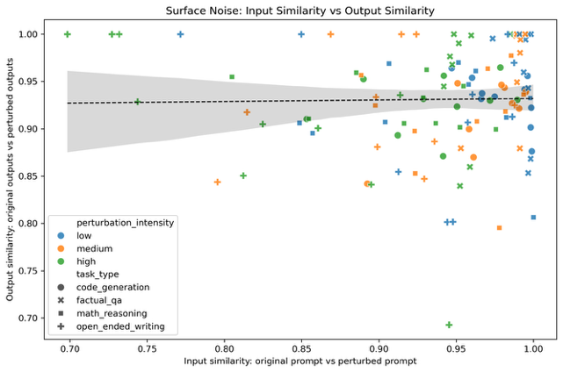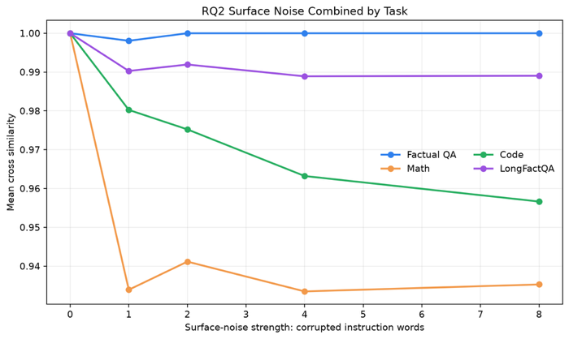
The first graph illustrates that the higher the number of corrupted instruction words, the lower the similarity of outputs.
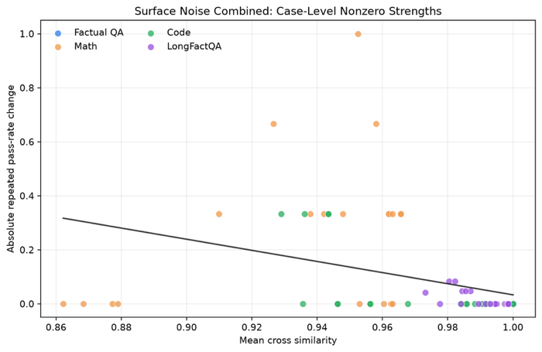
The second graph shows that the lower the similarity, the more drastically the output pass rate (output correctness) declines.
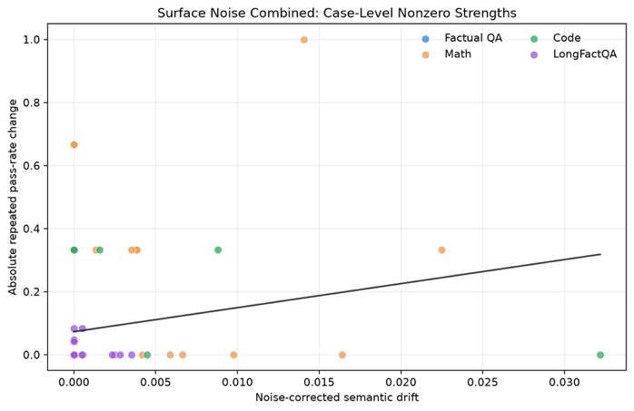
The third graph illustrates that the greater the similarity drop following sample noise correction, the more significantly the correctness declines.
(this part aims to deduce the relationship between input similarity, output similarity and output correctness, the data is currently going through trials as previous attempts were not successful, the last three graphs are from trials with a relatively small database)
- Evaluation and limitation
- Future work

Reference
[1] K. Zhu, J. Wang, J. Zhou, Z. Wang, H. Chen, Y. Wang, L. Yang, W. Ye, Y. Zhang, N. Z. Gong, and X. Xie, “PromptBench: Towards evaluating the robustness of large language models on adversarial prompts,” arXiv:2306.04528, 2023.
[2] A. Agrawal, L. Alazraki, S. Honarvar, and M. Rei, “Enhancing LLM robustness to perturbed instructions: An empirical study,” arXiv:2504.02733, 2025.
[3] A. Chatterjee, H. S. V. N. S. K. Renduchintala, S. Bhatia, and T. Chakraborty, “POSIX: A prompt sensitivity index for large language models,” arXiv:2410.02185, 2024.
[4] F. Errica, D. Sanvito, G. Siracusano, and R. Bifulco, “What did I do wrong? Quantifying LLMs’ sensitivity and consistency to prompt engineering,” arXiv:2406.12334 (2024)
[5] J. Haase, J. Gonnermann-M¨uller, P. H. P. Hanel, N. Leins, T. Kosch, J. Mendling, and S. Pokutta, “Within-model vs. between-prompt variability in large language models for creative tasks,” arXiv:2601.21339, 2026.
[6] N. Reimers and I. Gurevych, “Sentence-BERT: Sentence embeddings using Siamese BERT- networks,” in Proc. 2019 Conf. Empirical Methods in Natural Language Processing and 9th Int. Joint Conf. Natural Language Processing (EMNLP-IJCNLP), Hong Kong, China, 2019, pp. 3982–3992.

